

Progress Report 5
Ryan Schader
Name:
Project Title:
RISC-V RV32I CPU on an FPGA

Tell us about last week’s goals. How did they go?

To get all of the possible points for this section, write at least three sentences for each goal. Describe what each goal was and how you accomplished it (or what happened to prevent you from accomplishing it).

Goal #1: Clarify the core architecture
I reviewed the architecture document against the VHDL on October 12. I clarified reset PC zero, x0 protection and the one-cycle memory response, and saved a state diagram. The review records the GPIO map at that date; the current JTAG UART map is identified in the evidence appendix.
Status: Complete

Goal #2: Check decoder control signals
I added a focused decoder test for ADDI, LW, SW, BEQ and JAL, plus an illegal instruction and recovery. All seven cases passed on October 15, including immediate and full control-record assertions. I saved GHW and VCD traces, a readable waveform and a short explanation.
Status: Complete

Goal #3: Add a focused reset simulation
I added a core reset test using the real RAM and memory bus. Three injected resets passed on October 15, checking request suppression, restart at PC zero, register clearing and store acceptance timing. I saved the raw traces and a waveform explaining canceled and committed stores.
Status: Complete

Set three goals to work on next week.

Progress reports are individual assignments. That means you will be setting goals that you yourself intend to accomplish this week. Be specific; set goals that can be completed in one or two weeks.
As you work on your goals, make sure to take at least one picture or screenshot to show what you have done. The picture or screenshot will need to be submitted in your next progress report.
To get all of the possible points for this section, write at least three sentences for each goal. Describe what the goal is and how you plan to accomplish it.

Goal #1: Extend reset coverage
I will add reset cases during instruction fetch and load response cycles. I will check that a canceled load never writes a register and that the next fetch restarts at zero. I will save assertions and waveforms for each case.

Goal #2: Add a mixed RAM program
I will add one mixed program with a backward branch, arithmetic and RAM loads and stores. I will compare its retirement trace and final data against independent expected values. I will save the passing simulation log and a short coverage summary.

Goal #3: Build the current JTAG design
I will generate the Intel JTAG UART IP and attempt a fresh Quartus build of the current loader design. I will save the tool versions, fit and timing results, or the exact blocker. I will keep physical board validation pending until a current image is ready.

Visual Communication

Each report must be accompanied by an updated schedule in the form of a Gantt chart. You need to include the version from the previous progress report and the updated chart for next week. Paste them below or save the charts as pdfs and upload them separately.

Each report must also be accompanied by evidence of your work. This can be a photo, screenshot, graph, chart, code snippet, data table, or any other visual evidence that we discuss in class. Paste it below or upload it as a separate file.
Progress Report 5 schedule and verification dates
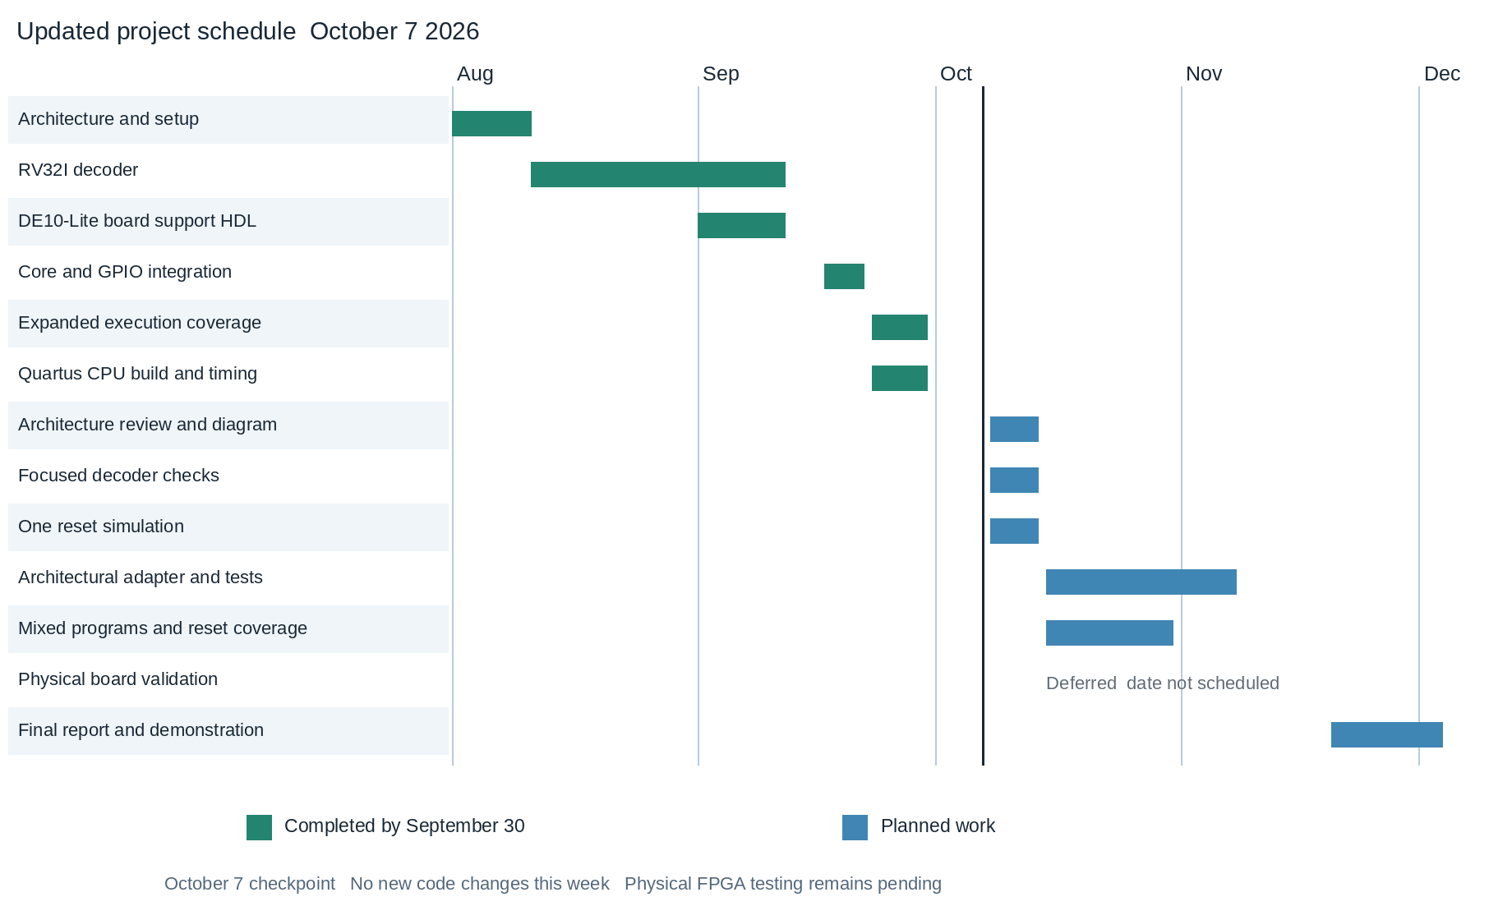
Previous schedule from Report 4.
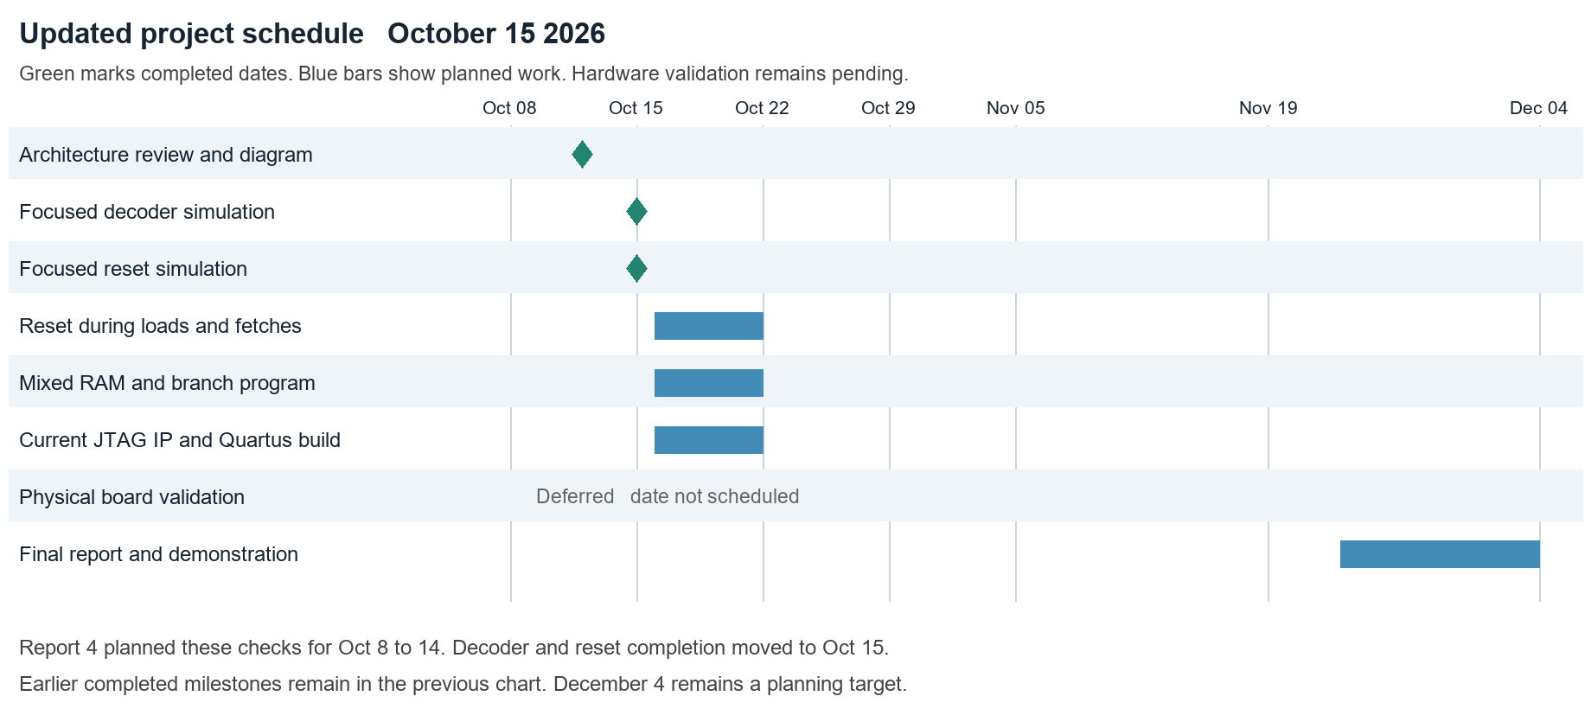
Updated schedule. Architecture review completed October 12; decoder and reset checks completed October 15. Next-week goals target October 22. Physical board validation remains unscheduled.
Goal 1 architecture review complete
Completed October 12 2026. I checked the core, register file, bus and memory map, clarified docs/architecture.md and saved the state diagram below. The diagram shows sequential states of one instruction in flight. It is not a pipeline.
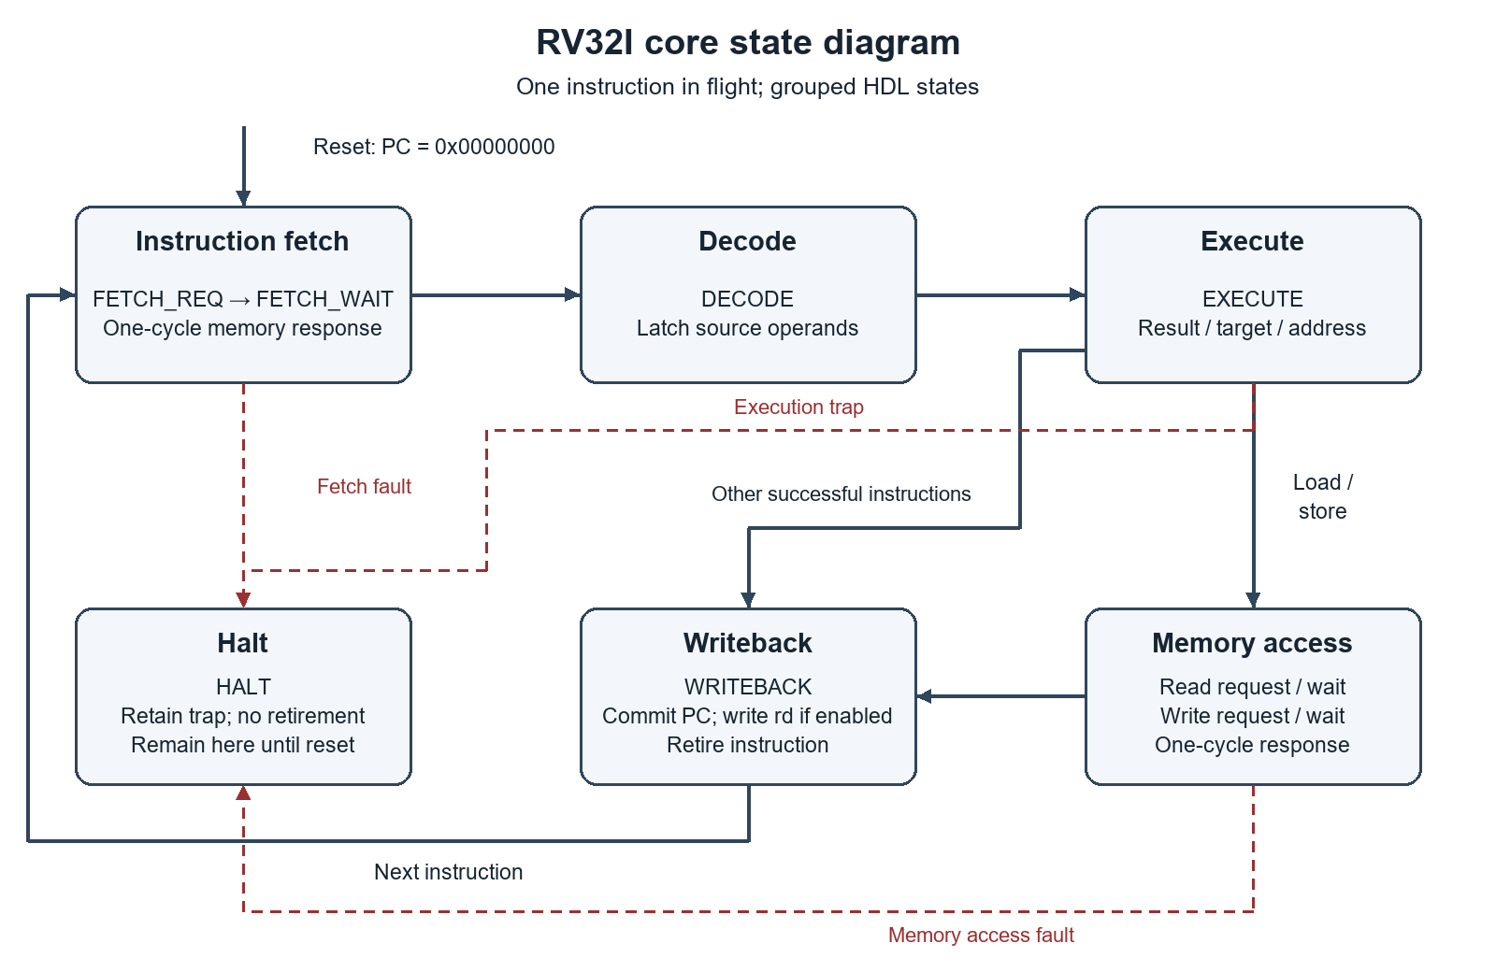
Figure 1. Core states grouped into instruction fetch, decode, execute, memory access, writeback and halt. A request is accepted at edge N and its registered response is consumed at edge N plus 1. A valid store commits at its acceptance edge.
Reset sets PC to 0x00000000 on an active edge and suppresses requests until release. Register x0 reads zero and ignores writes; a load to x0 still accesses memory and can fault. Fetch, execution and memory faults enter HALT without retirement. Reset leaves HALT and restarts fetch.
The October 12 review describes the earlier GPIO implementation. The current source replaces GPIO with JTAG UART: 0x40000000 is TX, 0x40000004 is RX, and 0x40000008 is status. ROM remains 16 KiB at 0x00000000 and RAM is 16 KiB at 0x00010000; RAM now also supports instruction fetch. The address reuse changes peripheral meaning, not the core memory timing.
Current project context: October 14 work added a USB-Blaster JTAG UART, a CRC32 ROM loader and execution of uploaded programs from RAM. The October 15 regression passes ten benches, thirteen directed programs and five host checks; local adapter self-tests and GHDL synthesis also pass. Native Intel IP, current Quartus fit/timing and physical JTAG operation remain pending.
Goal 2 decoder simulation complete
Completed October 15 2026. I added tb_decoder_focused with seven fixed instructions and assertions for legality, raw register fields, the immediate and every control field. All seven cases pass at 70 ns; the exhaustive decoder test also passes 270,612 cases.
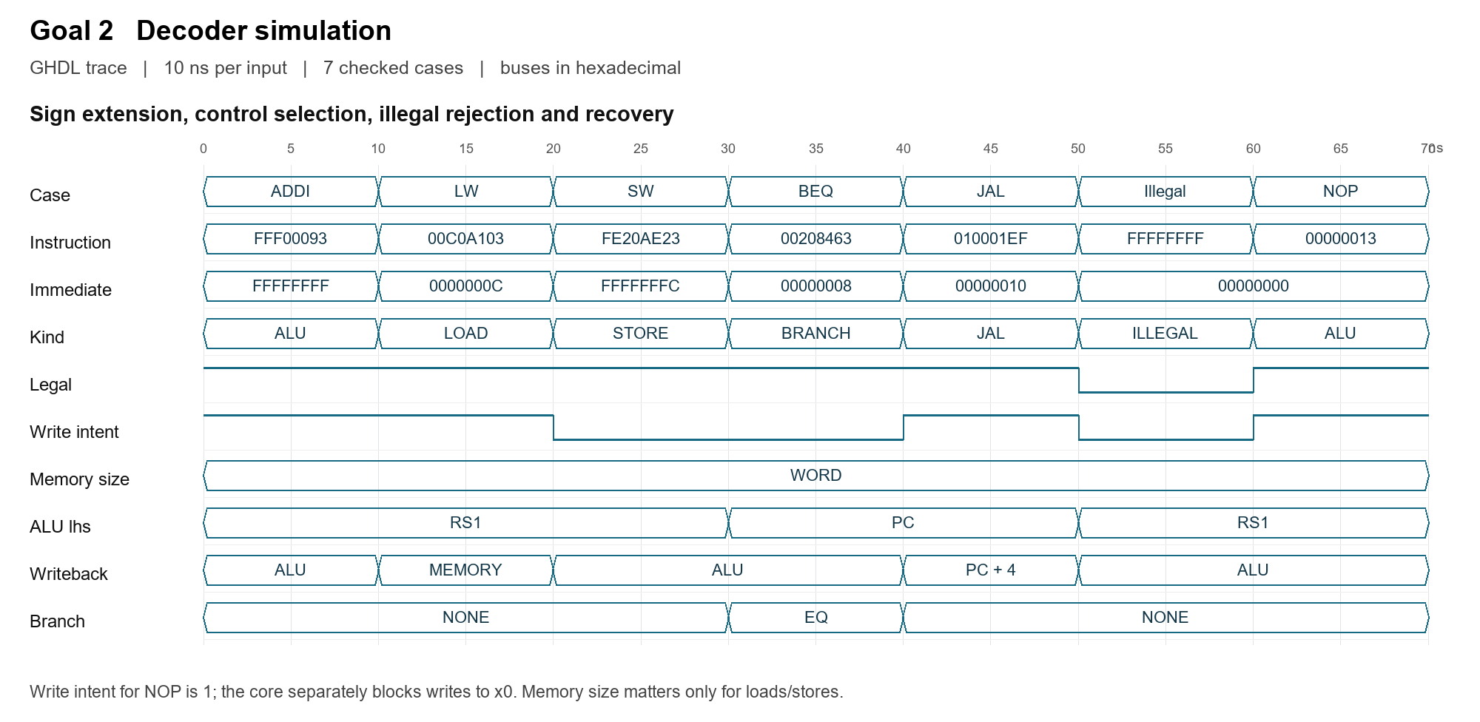
Figure 2. Actual GHDL VCD transitions. Each instruction is held for 10 ns; assertions sample after 1 ns. The decoder is combinational, so this is a sequence of input cases rather than CPU clock cycles.
The waveform shows FFFFFFFF for ADDI -1 and FFFFFFFC for SW -4, confirming sign extension. LW and SW select word accesses. ADDI, LW and JAL request a destination write; SW and BEQ do not. BEQ selects the PC and equality comparison, while JAL selects PC plus 4 for writeback.
At 50 ns, FFFFFFFF is rejected: legal and write intent drop to zero and the immediate clears. NOP restores legal decoding at 60 ns. NOP still has write intent, but the core separately blocks writes to x0. Default memory-size fields on non-memory instructions do not cause a memory request.
Saved evidence: evidence/goal-2-decoder.ghw and .vcd; goal-2-decoder-waveform.png; goal-2-decoder-simulation.txt. Source: sim/tb_decoder_focused.vhd and rtl/pkg/rv32i_pkg.vhd. GHW preserves typed records; VCD exposes enum-position aliases translated into names in the figure.
Goal 3 reset simulation complete
Completed October 15 2026. The focused test uses the actual core, register file, memory bus and RAM with an independent ROM. Three injected resets pass all assertions; the test finishes at 1165 ns.
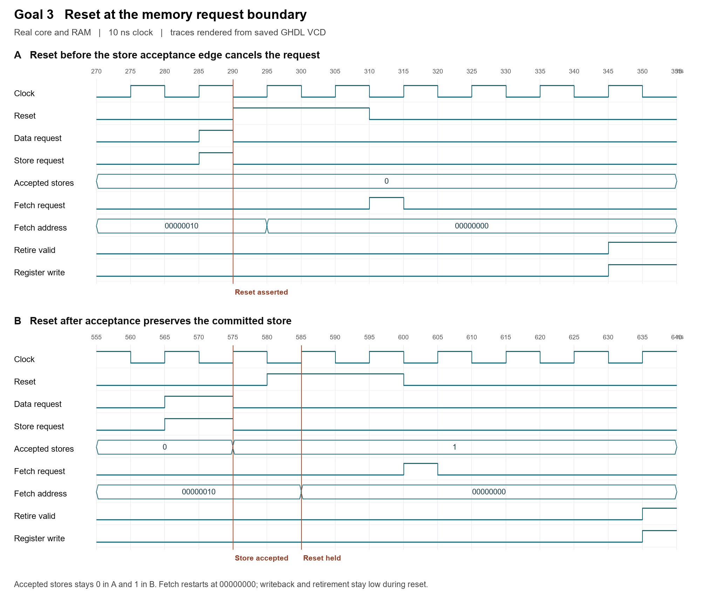
Figure 3. Store request boundaries in the saved GHDL trace. All instruction/data requests, register-write enable and retirement are suppressed while reset is asserted.
Panel A shows reset at 290 ns, before the store can be accepted at a rising edge. The request drops and the accepted-store count stays zero. Releasing reset at 310 ns starts a fetch at address zero. Panel B shows a store accepted at 575 ns followed by reset at 580 ns; the count stays one, and a later load reads 0x55 from the preserved RAM word.
A third reset at 930 ns suppresses an ADDI writeback before its commit edge. After each restart, ADDI x7,x6,1 returns 1 even though x6 previously held 0x55, confirming register clearing. These cases cover the focused goal; reset across every state and physical board timing remain future work.

